Project Report on

"E- Learning Website"

Submitted in partial fulfilment of the requirements of . the Value Addition Program on

WEB DEVLOPMENT

by

|  |  |
| --- | --- |
| Roll No | Student Name |
| B09 | Yash Ghare |
| A41 | Aditya Patil |
| C42 | Gaurav Yadav |
| A06 | Sujal Kalamkar |
| D33 | Aayush Vishwakarma |
| D27 | Smit Gawand |

Supervisor

Dr. Nidhi Singh

 

First Year Department

Vishwaniketan Institute of Management Entrepreneurship and

Engineering

Technology Academic Year: 2021 - 2022

Table of Contents

1.Introduction ........................................................................................................................

1. Objective ............................................................................................................................
2. Why Online Learning Website? .........................................................................................
3. Advantages Of E-Learning ..................................................................................................
4. Mode Of E-Learning……………………………………………………………………………………………………………………
5. Website Interface………………………………………………………………………………………………………………………

6.1. Home

6.2. Courses

6.3. Testimonials

6.4. Service

6.5. Contact

7. Future Scope…………………………………………………………………………………………………………………..

# **Introduction**

E-Learning is an alternative to a traditional classroom learning experience and is often referred to as "online learning", "virtual learning", "mobile learning", "digital learning".

E-Learning involves using primarily the internet and one or more other technologies involving one/two-way transmissions through open broadcast,broadband lines, satellite, or wireless communications devices or audio/video conferencing.

# E-learning, also referred to as online learning or electronic learning, is the acquisition of knowledge which takes place through electronic technologies and media. In simple language, e-learning is defined as “[learning that is enabled electronically](http://itdl.org/Journal/Jan_15/Jan15.pdf#page=34)”. Typically, e-learning is conducted on the Internet, where students can access their learning materials online at any place and time. E-Learning most often takes place in the form of online courses, online degrees, or online programs.

# **2.Objective**

### **The Major Goals Of eLearning**

There are certain goals when it comes to eLearning and some of these are to:

* Enhance the quality of learning and teaching
* Meet the learning style or needs of students
* Improve the efficiency and effectiveness
* Improve user-accessibility and time flexibility to engage learners in the learning process

eLearning is vast and an expanding platform with huge prospective in higher education. Since there are many challenges in making eLearning effective, it is important to know how to manage it and access to the resources. Take a minute and just imagine if one is not having the roadmap to guide from start to finish is actually like plunging into eLearning without an effective strategy because learners would be lost in the learning content.

# **3.Why E-Learning Website ?**

**1. Traditional training just isn’t enough anymore.** In the past, organizations would turn to training for one-off teaching events in the effort to rectify a problem, or to help to facilitate change. The problem here is that people are constantly learning, and often a message needs to be heard more than once before it is fully understood and acted upon. Learners need reinforcement beyond the training.

**2. ELearning produces measurable results.** [**Many studies over the years have shown**](https://www.learndash.com/14-interesting-elearning-facts/) that elearning can increase a company’s ROI, improve student’s grades in school, and help organizations to retain their talent. ELearning effectively reinforces the objectives of an organization and can cover five times the amount of material compared to traditional classroom courses.

**3. ELearning is conducive to positive organizational growth.** No matter what industry your in, if your organization has a strong elearning culture then you are 46%  more likely to be your industry’s leader. Employee productivity will increase as well, which directly impacts ROI, and therefore makes you more competitive in your market space – including the ability to attract and maintain the top talent. All of this directly contributes to the growth of the organization.

**4.Advantages of E-learning**

1. [E-Learning is student-centered](https://e-student.org/advantages-of-e-learning/#e-learning-is-student-centered)
2. [E-Learning is cost-effective](https://e-student.org/advantages-of-e-learning/#e-learning-is-cost-effective)
3. [Individual learning styles](https://e-student.org/advantages-of-e-learning/#individual-learning-styles)
4. [Customizable learning environments](https://e-student.org/advantages-of-e-learning/#customizable-learning-environments)
5. [E-Learning fully utilizes analytics](https://e-student.org/advantages-of-e-learning/#e-learning-fully-utilizes-analytics)
6. [Online learning could solve teacher scarcity](https://e-student.org/advantages-of-e-learning/#online-learning-could-solve-teacher-scarcity)
7. [E-Learning is environmentally friendly](https://e-student.org/advantages-of-e-learning/#e-learning-is-environmentally-friendly)
8. [No need for textbooks](https://e-student.org/advantages-of-e-learning/#no-need-for-textbooks)

9. [Online learning is time-efficient](https://e-student.org/advantages-of-e-learning/#online-learning-is-time-efficient)

**5. Modes Of E- Learning**

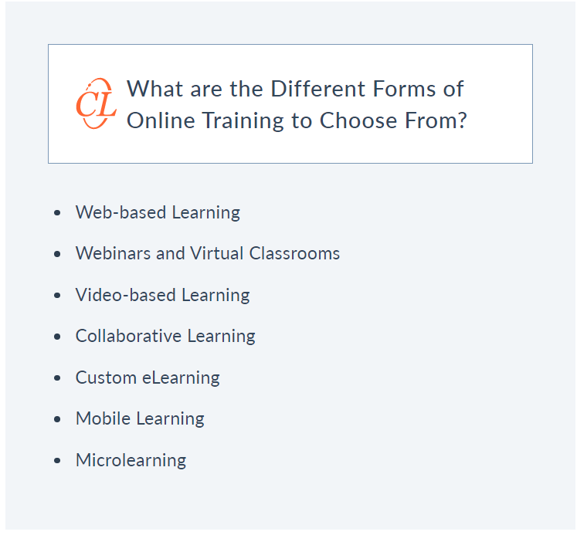

**6 . Website Interface**

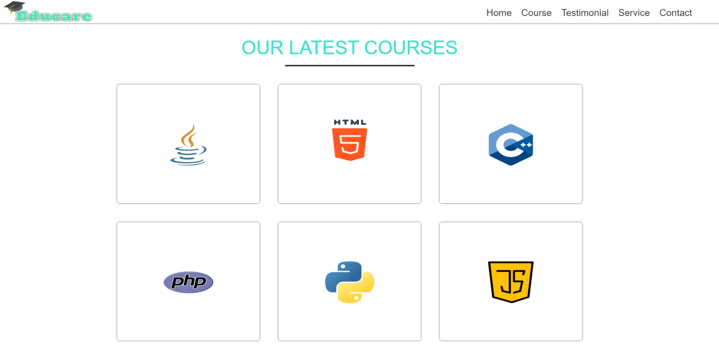



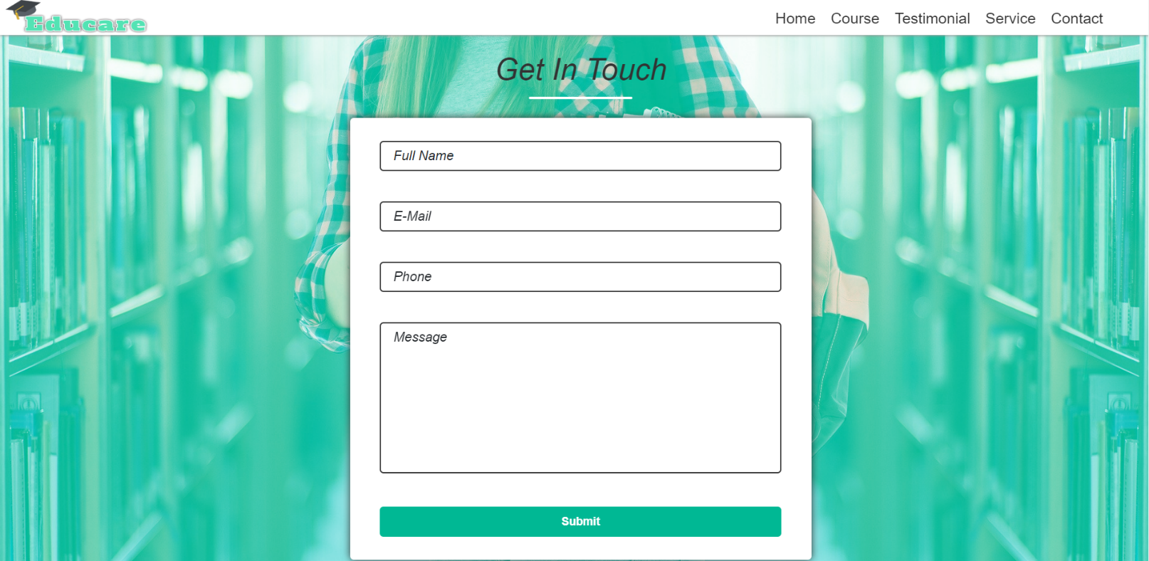

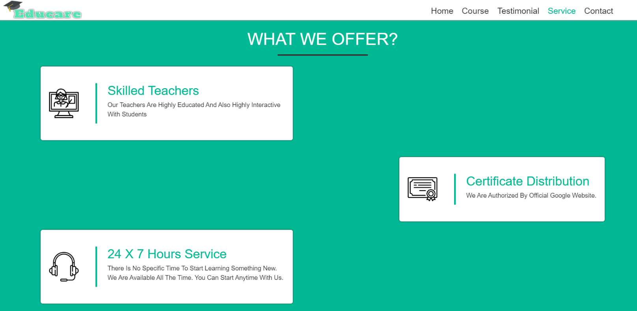

**What Makes an E-Learning Project Successful?**

Many factors contribute to a successful e-learning program, but the top two are:

1. A production process that uses the right apps
2. Solid instructional design

Let’s take a closer look at these two essential elements.

**Apps**

Powerful apps let you create the functionality and interactivity that you want for your learners. They help you make e-learning that looks and works great, which goes a long way toward a successful e-learning course.

The more user-friendly the app, the less time you’ll spend on technical issues. This frees you up to commit to the instructional design to craft a great learning experience.

**Instructional Design**

One way organizations measure the success of an e-learning project is by how much the learner’s knowledge and skills have improved after they’ve taken the course. To provide your learners with the best odds, you should have content that is designed in an instructionally sound manner. Instructional design is all about creating educational experiences that maximize learning and present content in the most effective way.

**7.Future scope**

The developing pattern of digital learning is profiting society from multiple points of view. The across the board enrollment in online courses is adding to the improvement in digital skills on an enormous scale. Society is profiting in general from improved communication, innovation, and collaboration skills.

[Online courses](https://www.createonlineacademy.com/sign-up/) are making it simpler to speak with others and associate with individuals around the world, making a worldwide network. This is one of the advantages of [eLearning](https://www.createonlineacademy.com/sign-up/) for society.

E-learning is here to stay. As computer ownership grows across the globe e-learning becomes increasingly viable and accessible. Internet connection speeds are increasing, and with that, opportunities for more multimedia training methods arise.

With the immense improvement of mobile networks in the past few years and the increase in telecommuting, taking all the awesome features of e-learning on the road is a reality with smartphones and other portable devices. Technologies such as social media are also transforming education constantly.